CS319 - Group 1

Fall 2016

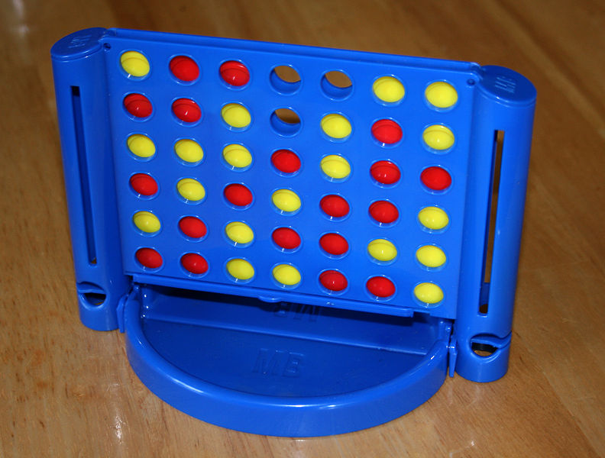

We decided to create a “Connect Four” like game with bonuses and different size game boards. We think that everyone, in every age, who wants to play a boardgame and have fun may enjoy our game. This will be a game for 2 players. They will compete with each other, and the first one who can connect four disks. We planned to use keyboard as the input source of this game. In other word, the players will make their moves by using the keyboard.

In addition to the original game, we are planning to add time limitations, bonuses and different game board sizes to make the gaming experience more fun, and we think that all of these additional features will be important for the system. Also, we are aware that the user may have some difficulties with time limitation and the logic of the game in the beginning and we hope that they will get used to those.

For the future of this project, if it becomes successful, we may consider to integrating this game with social media’s gaming platforms or create apps for smart phones.

The size and the complexity of this game can be considered as medium since we have a time limitation to analyze, design and implement the project.

During the implementation of this game, we are planning to use Java programming language since it is a preferable object-oriented programming language, very powerful with respect to GUI, and we all are familiar with it because of our previous courses.

And, since we are planning to reproduce a certain program, we may make a research about its previous versions; make reverse engineering on those projects to obtain the main pattern of the game. Also we may do apply this to a partially complete project about our topic and by the pattern we obtained, we may provide a more complicated and finalized project.

For more information about “Connected Four”, you may visit: <https://en.wikipedia.org/wiki/Connect_Four>